Output power during the half period
Linear functions are boring, let’s curve it like that:
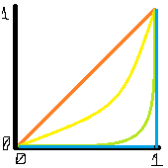
- f(x) = x
- …

Rounding the curve
Let’s start from circle equation

Move circle up

Convert into single function (red graph)

Let’s find the middle part of the curve we’re interested in (intersection with green line)
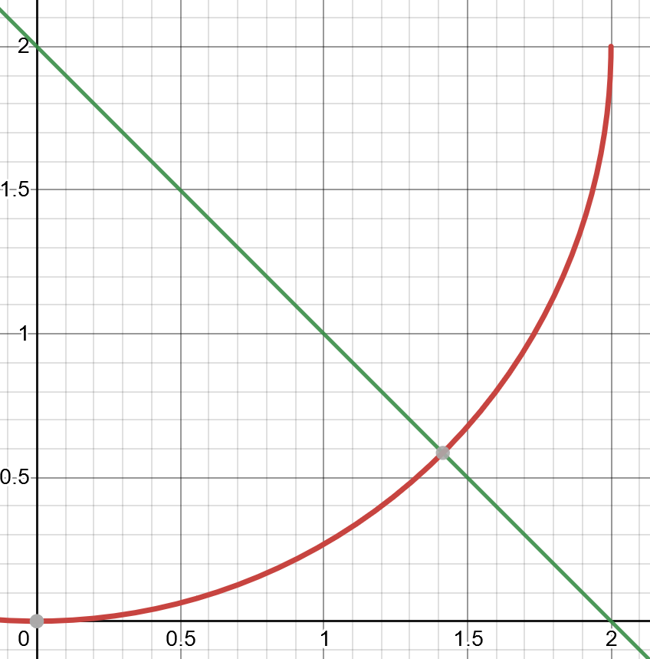
Apparently we don’t care about that intersection.
Intersection with y = x – b (yellow line)
We need that line to intersect two points at distance exactly 1:
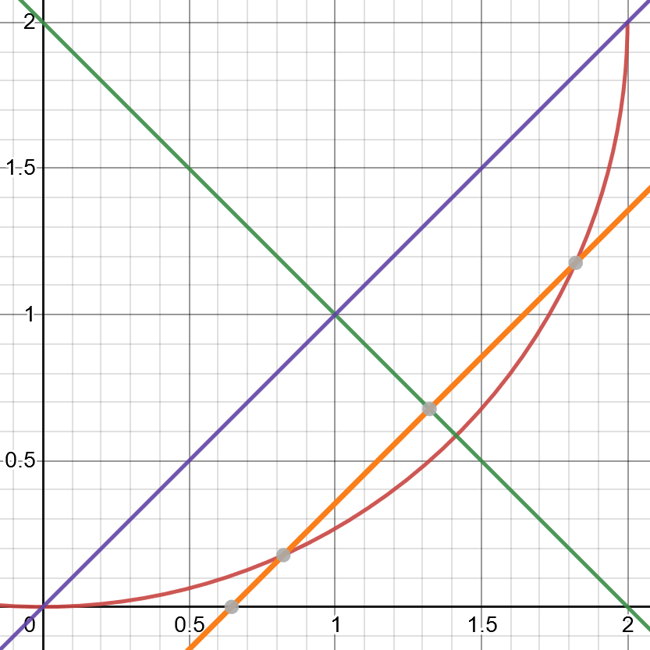

We need smaller |b| from that, resulting in yellow line y = x – b

Now we need first intersection point with our circle (red curve), it will be our new zero:
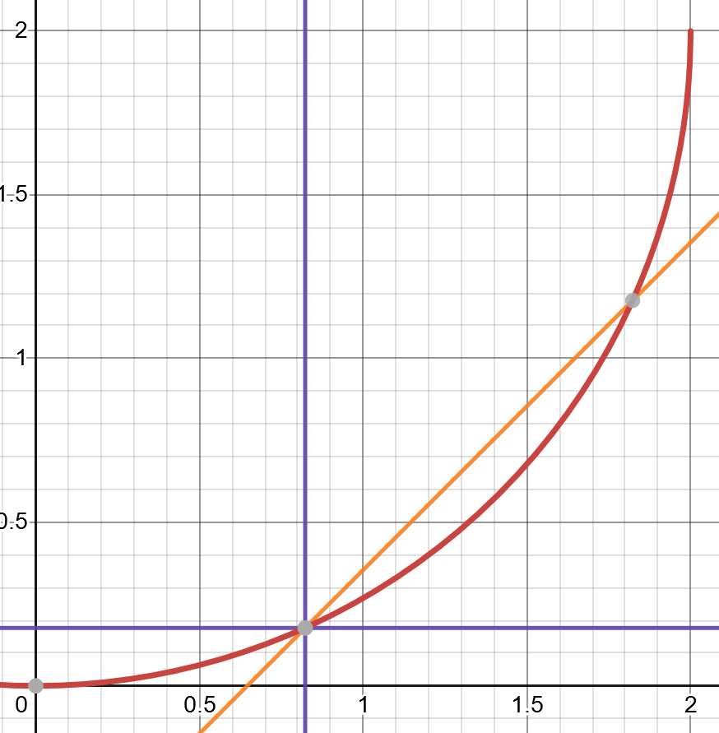
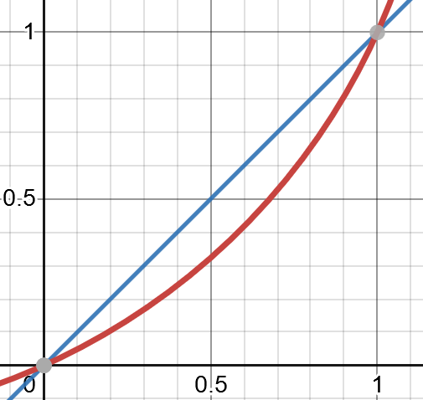
Now lets move our circle by those offsets

Resources
- Graph generator https://www.desmos.com/calculator

